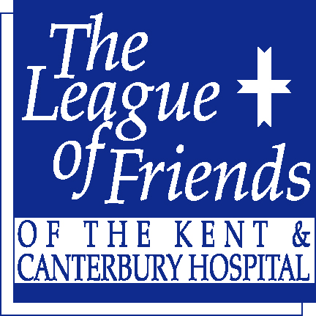
Registered Charity No: 1155088
Gift Aid declaration

The League of Friends of the Kent & Canterbury Hospital CIO
Please treat
□ The enclosed gift/subscription of £ _____________ as a Gift Aid donation; OR
□ All gifts of money that I make today and in the future as Gift Aid donations; OR
□ All gifts of money that I have made in the past 4 years and all future gifts of money that I make from the date of this declaration as Gift Aid donations.
Please tick the appropriate box

You must pay an amount of Income Tax and/or Capital Gains Tax for each tax year (6 April one year to 5 April the next) that is at least equal to the amount of tax that the charity will reclaim on your gifts for that tax year.

Your details

Title ______ Initial(s) ________ Surname ___________________________________

Home address ________________________________________________________

_______________________________________________ Post Code ____________

Signature ______________________________ Date _________________________

Please notify the League of Friends of the Kent & Canterbury Hospital if you:
- Want to cancel this declaration
- Change your name or home address
- No longer pay sufficient tax on your income and/or capital gains.

The League of Friends of the
Kent & Canterbury Hospital
Ethelbert Road, Canterbury,
Kent CT1 3NG www.lofkch.org.uk

Tax claimed by us
The League of Friends can reclaim 25p of tax on every £1 you give on or after 6 April 2008.

If you pay Income Tax at the higher rate, you must include all your Gift Aid donations on your Self Assessment tax return if you want to receive the additional tax relief due to you.

